**Python Configuration Instructions**

**Setting Up Your Environment:**

The *environment* is one of the most important aspects of programming, and it can be frustrating for newer programmers to figure out. In essence, all "environment" really means is "setting up your computer properly so that it can run Python code". Please follow the instructions below:

1. Go to <https://www.continuum.io/downloads> and download the appropriate Anaconda package for your operating system (Windows/Mac/Linux). You'll want the Python 3.X version (as of this writing, 3.5). Unless your computer is genuinely ancient, it will be the 64-bit install. Anaconda has a few programs inside of it.

2. Install Anaconda using all the default settings, just like any other program. Just keep clicking next. When finished, restart your computer.

3a. On Windows go to your Start menu and find Anaconda3 (on Mac, this should be in your Applications tab). There are only two programs that we need to worry about from the Anaconda install: **Jupyter Notebook** and **iPython**. Run the iPython program and wait for the window to appear.

3b. (If 3a worked without a hitch, skip this step.) **NOTE:**Some versions of Windows and Mac have been reported as not creating the appropriate start menu/Applications folder. If this occurs to you, don't fret. Rather, open up the command prompt (Windows, see http://www.digitalcitizen.life/7-ways-launch-command-prompt-windows-7-windows-8 for more assistance)/Terminal (Mac, see http://www.wikihow.com/Get-to-the-Command-Line-on-a-Mac for more assistance) and type in "ipython" (without quotes). Press Enter, and wait for iPython to load in the command prompt/terminal. It may take a minute.

4. Type:

print("Hello World")

on the first line (where it says **In [1]:**). Then press Enter. If all went well, IPython will respond back to you with Hello World right below it. This indicates that Python has been successfully installed.

Congratulations!

**Loading Jupyter Notebook**

The previous instructions installed Jupyter Notebook for you. Now you need to use it. If you were able to find the Jupyter Notebook icon back in Step 3a of *Setting Up Your Environment*, you can simply use that. Otherwise, follow Step 3b, but instead of typing in ipython, instead type in “jupyter notebook” (without quotes) and press Enter.

It may take a few minutes, but eventually your default web browser will appear with a new tab open. It should look like this:

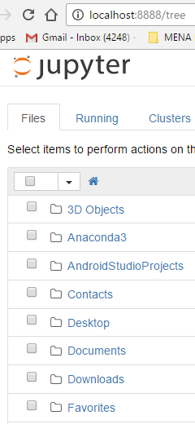

Remember, even though Jupyter Notebook opens in your web browser, it’s not actually on the internet. It does NOT require an active internet connection to function.

Minimize the Command Prompt/Terminal window that you used to open Jupyter Notebook but **do not exit it**. Now, save the web browser link to your bookmarks so you can find it in the future. **However**, remember that it will *only work* if you’ve opened that Command Prompt/Terminal window beforehand. Entering in “jupyter notebook” essentially creates a miniature website for your machine only.

Now, the folders that you see in the Jupyter Notebook window actually refer to real, physical folders on your computer. The directory that you’re in by default is a real directory that you can access normally by looking through folders.

Different operating systems (Windows, Mac) sometimes make the default folder in different places, so we’re going to figure out next how to find your specific folder.

**Creating Your First Notebook**

Let’s create our first Notebook, which we’ll use to write our Python code. On the top-right area of the screen, you’ll see the following buttons:

 Using the New dropdown menu, at the bottom there should be an option under the Notebooks sub-menu that looks like Python [conda root] or Python [default]. Click on that menu option, and a new tab will appear on your browser. Give it a moment to load, and you should see a new tab that looks like this:

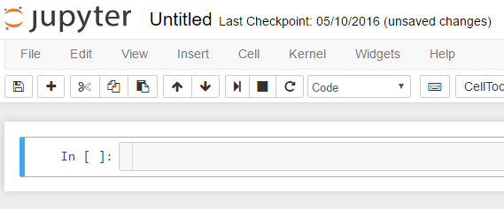

First, click the Untitled text on top and change the name to Practice Notebook. Then, in the open area to the right of where it says In [ ]:, enter in the following two lines (don’t worry about what they mean for now):

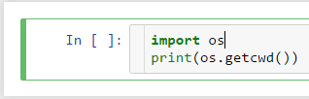

Finally, press Ctrl + Enter at the same time. Your default directory will appear right under it. This is the directory that we’ll be using. Press Ctrl + S (just like you would for Microsoft Word) to save the Notebook.

**Navigating the Notebook Structure**

The Notebook structure has a lot of advantages over a regular text document. It only runs the Python code in a certain cell, the cell that you last clicked on (it will be outlined in Green). This lets you control what, precisely, you want to run at any given time.

Jupyter Notebook runs on keyboard shortcuts, so it’s important to learn the basic ones. Try testing them all out (click on the first Cell so that it’s outlined in green first):

Ctrl + B: Create a new cell below  
Ctrl + A: Create a new cell above  
Ctrl + D D (D twice): Delete the currently green-highlighted cell permanently  
Ctrl + Enter: Run the currently green-highlighted cell

**Restarting the Notebook**

If for some reason the Notebook ever stops processing when you press Ctrl + Enter, you can always restart the notebook by clicking the Kernel tab on the top menu, then clicking Restart & Clear Output:

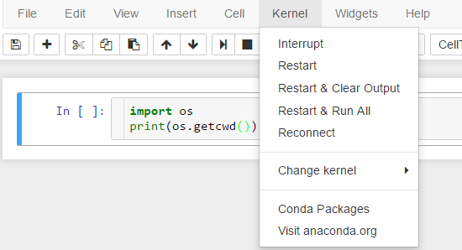

Give it a minute, but eventually you’ll see all output disappear.

**More Complete Guide to Jupyter Notebook**

This, of course, is a very rough run-through of the basics. For a more complete guide, you can read the official documentation at http://jupyter-notebook-beginner-guide.readthedocs.io/en/latest/execute.html.

**Further Instructions**

To use my sample notebooks and for further instructions, head on over to https://github.com/Starstorm/Social-Science-Python to learn more.